2015-2016学年 第1学期
2015 级《计算机导论》考试试题
考试时间：2015年12月日
班级 学号 姓名

- 要求答案写在答题纸上，不必抄题；
- 要求在每个大题号(I, II, III,IV,V)前划一个满页的横线，以便教师批阅；
- 要求在答题纸和试题纸上都写上班级、学号和姓名，交卷时一并交上来。

- Choice Questions(25 questions, 1 score for each question)

bdbdc cacba caabd cccab caada

- Questions(5 questions, 4 scores for each question)

  - What are the components of an operating system?
A: Memory Manager, Process Manager, Device Manager and File Manager
  - Name the layers of the OSI model.
A: Physical layer, Data link layer, Network layer, Transport layer, Session layer, Presentation layer and Application layer.
  - What are four necessary conditions for deadlock?
A: mutual exclusion, resource holding, no preemption and circular waiting.
  - What are the subsystems of the von Neumann computer model?
A: Memory, arithmetic logic unit, control unit, and input/output.
  - Name four types of network connecting devices.
A: repeater, bridge, router and gateway.

- Calculation(4 subjects, 5 scores for each subject)

- Using an 8-bit allocation, first convert the following numbers to two’s complement, do the operation, and fill the blanks with the result in hexadecimal.
A | B | A  (two’s complement in hexadecimal) | B  (two’s complement in hexadecimal) | A + B  (two’s complement in hexadecimal)
19 | -23 | x13 | xE9 | xFC
-42 | 71 | xD6 | X47 | x1D
127 | -128 | x7F | x80 | xFF
-32 | -105 | xE0 | x97 | x77(overflow)

- Show the result of the following operations, and then convert the result to hexadecimal.
Operations | results (in hexadecimal)
x99 XOR xFF | x66
X47 AND x10 | x00
( NOT x51 ) OR xCC | xEE
( xFF XOR xBB ) OR ( xFF AND xBB ) | xFF

- Change the -7.1875 decimal numbers to binary numbers, and show it in 32-bit IEEE format, and then convert the result to hexadecimal.
A: -7.1875 → -111.0011 → -2²×1.110011 → 1 10000001 11001100000000000000000
→ xC0E60000
- A computer has 64MB of memory. Each word is 4 bytes. How many bits are needed to address each single word in memory?
A: log₂ (2²⁶÷2²) ＝ 24

- Analyzing(3 subjects)

- ( 8 scores ) A computer with simple architecture is shown as below. The figure shows the memory and CPU before the execution of the program. Please describe the contents of memory location(200, 201 and 202) and registers(R1, R2, R3, I and PC) after the execution of the program.
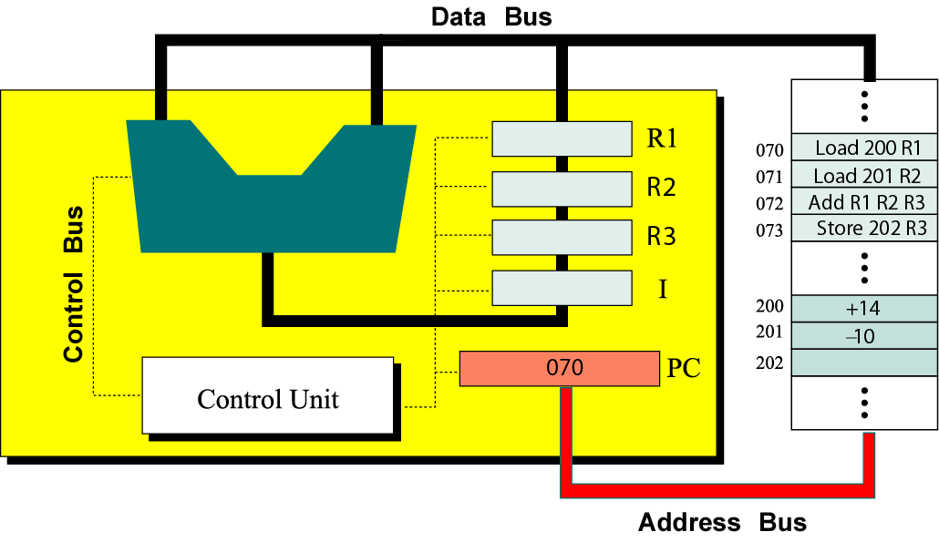
A: Memory location 200 : +14 Register R1 : +14
Memory location 201 : -10 Register R2 : -10
Memory location 202 : +4 Register R3 : +4
Register I : Store 202 R3
Register PC : 074
- ( 6 scores ) A list contains the following elements. Using the binary search algorithm, trace the steps followed to find 22. At each step, show the values of first, last and mid.
4, 7, 8, 10, 14, 21, 22, 36, 62, 77, 81, 91
A: 1) first = 0, last = 11, mid = 5, 22>21
2) first = 6, last = 11, mid = 8, 22<62
3) first = 6, last = 7, mid = 6, 22=22

- ( 6 scores ) Using the insertion sort algorithm, manually sort the following list and show your work in each pass.
23, 78, 45, 8, 32, 56
A:
23 ‖ 78 45 8 32 56
Pass 1: 23 78 ‖ 45 8 32 56
Pass 2: 23 45 78 ‖ 8 32 56
Pass 3: 8 23 45 78 ‖ 32 56
Pass 4: 8 23 32 45 78 ‖ 56
Pass 5: 8 23 32 45 56 78 ‖

- Design(2 subjects)

- ( 7 scores ) Write a recursive algorithm in pseudocode to find the Fibonacci value Fib(n) using following definition.
0 if n=0
Fib(n) ＝ 1 if n=1
Fib(n-1) + Fib(n-2) if n>1
A:
Fib
Input: n
1. if ( n = 0 )
then
1.1. return 0
else
1.2. if ( n = 1 )
then
1.2.1. return 1
else
1.2.2. return Fib(n-1)+Fib(n-2)
End if
End if
End

- ( 8 scores ) The ASCII codes for the uppercase letters A to Z are x41 to x5A. The ASCII codes for the lowercase letters a to z are x61 to x7A.
  - Convert the uppercase letters to the lowercase letters.
  - Convert the lowercase letters to the uppercase letters.
Show the mask and operation. Test with A←→a and Z←→z.
A:
a. Mask: 00100000

0 1 0 0 0 0 0 1 ← A 0 1 0 1 1 0 1 0 ← Z
OR 0 0 1 0 0 0 0 0 ← Mask OR 0 0 1 0 0 0 0 0 ← Mask
0 1 1 0 0 0 0 1 ← a 0 1 1 1 1 0 1 0 ← z

b. Mask: 11011111

0 1 1 0 0 0 0 1 ← a 0 1 1 1 1 0 1 0 ← z
AND 1 1 0 1 1 1 1 1 ← Mask AND 1 1 0 1 1 1 1 1 ← Mask
0 1 0 0 0 0 0 1 ← A 0 1 0 1 1 0 1 0 ← Z

